**Welcome**

This library management software must be a librarian or library management operator

There has three (3) section.

* **Student section**
* **Book section**
* **Book issue and return section**

Each section has few function to operate this software

1. **Student section**

* Student registration
* See all student record
* Delete a student record
* Search student (by student ID)
* Search student (by book ID) [if book are taken by which student]

1. **Book section**

* Book insert in library
* Book searching [to see existing details ]
* See all the book record
* Delete a book from library storage
* Delete all book from library storage

1. **Book issue and return section**

* Checking how many books copy are available for borrow
* Borrow book
* Return

**First operation this software follow some step and condition**

**Condition:**

* Still, This software only storage data at the prime memory (RAM) [so, if you terminate this program, you lost all the stored data]
* When you insert book and student name don’t make space in word.
* Before borrow books Student must be Register in software.
* One student can take only one Book at a time.
* When student going to take a book, he don’t borrow any books before

Demo/guides on how to use this software:

Index:

* **Insert some book**
* **See all books on store**
* **See only a book details (fine by book ID)**
* **Insert / Register some student**
* **See all student record**
* **Borrow books**
* **Check borrowed book stocks (should decreasing)**
* **Check student information who has borrow book**
* **Try to take another a book borrow again, who has already take a book**
* **Return borrowed book**
* **Check student information who has Return book**
* **Check borrowed book stocks (should increasing)**
* **Delete book from this program**
* **Delete student information from this program**
* **Delete all the information of student**
* **Delete all the information of book**
* **Terminate this program**

**Details:**

**1. Double click test.exe file and open software**

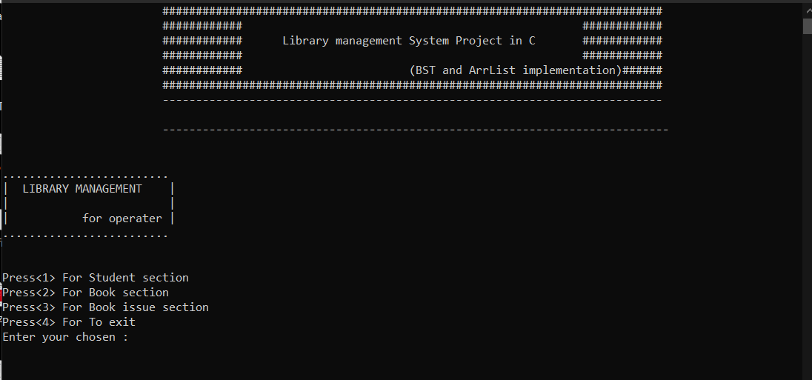

* + Press <2> for book section
  + Insert some book …….. press <1> for insert book
* 123456 c_programming_book zaman
* 234567 java_progamming_book tonmoy
* 345678 python_progrmming_book zubayer
* 456789 C++_programming_book mamun
* 334455 chinese_learning_book pias
* 223344 english_learning_book khan
* 123456 c_programming_book zaman
* 234567 java_progamming_book tonmoy
* 234567 java_progamming_book tonmoy
* 123456 c_programming_book zaman

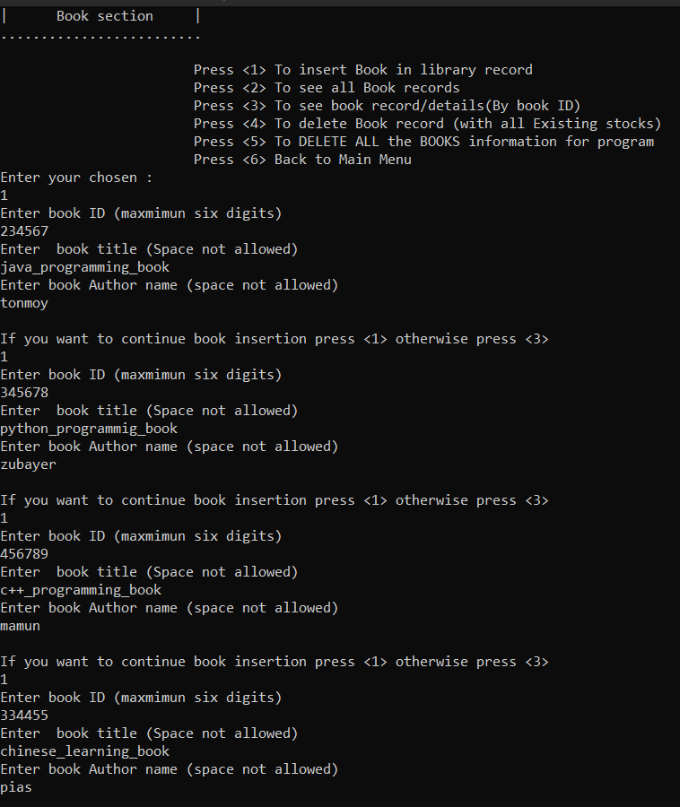

* Press <3> for move book section
* Press <a> for continue book section

**2. See all books on store**

* Press <a> to continue book section
* Press <2> to see all book records
* 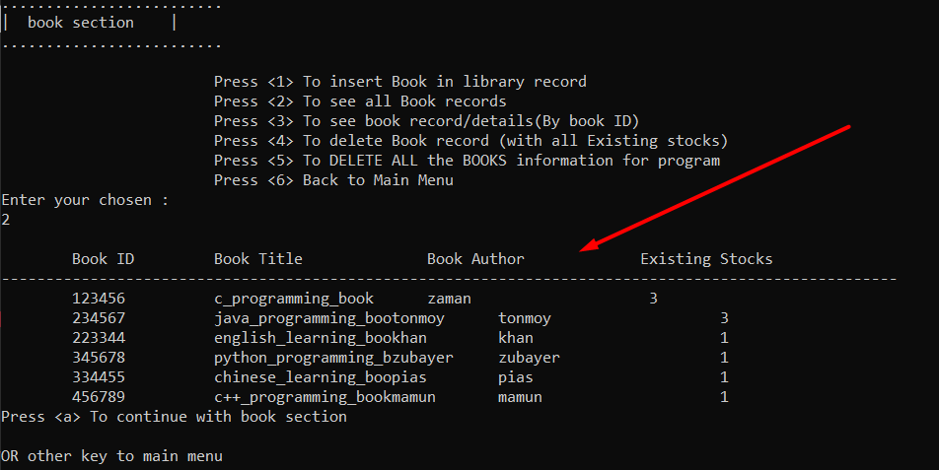
* Press <a> to continue with book section

**3. See only a book details (fine by book ID)**

* Press<3> to see a book record/details
* Enter book ID
* 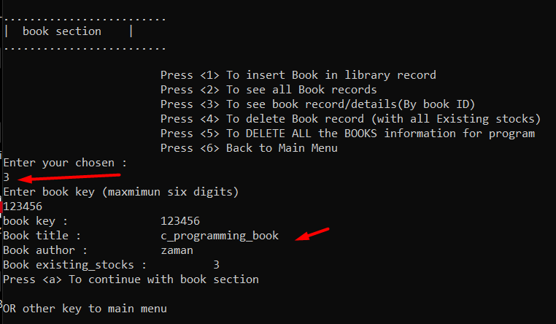
* Press <b> to move main menu
* Press <1> to continue with main menu

**4. Insert/ Register some student**

* Press <1> student section
* Enter those details

|  |  |  |  |
| --- | --- | --- | --- |
| Student id | Student name | Gender  (male for 1)  (female for 0) | Mobile number |
| 100001 | khan | 1 | 12345678 |
| 100002 | kamrul | 1 | 23456786 |
| 100003 | aman | 1 | 4321234 |
| 100004 | manik | 1 | 345677654 |
| 100006 | rito | 0 | 223344556 |
| 100005 | hajar | 0 | 112233445 |

* Press <3> to move student section
* Press <1> to continue with student section

**5. To see all student record**

* Press <2>
* 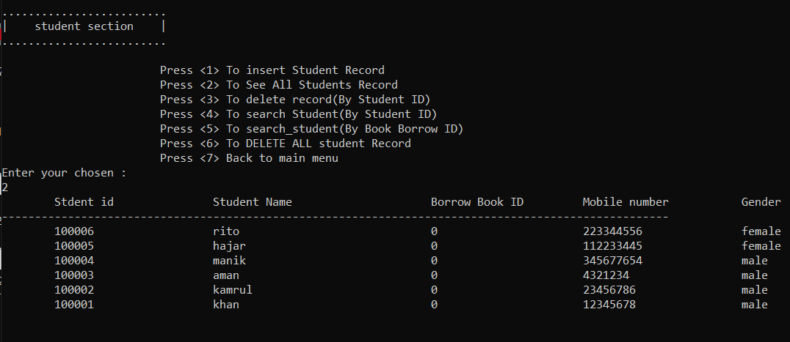
* Press <1> to continue with student section
* Press <7> for move to main menu

**6. Borrow book:**

* Press <3> to move book issue section
* Press <2> to Borrow a book
* Enter student id “10004”
* Enter Book id “123456”
* 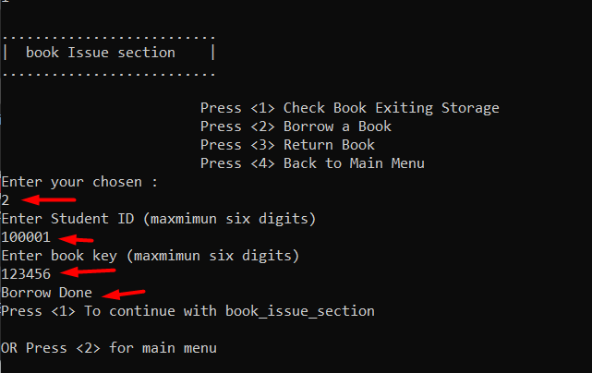
* Press <1> continue with book issue section1

**7. Check borrowed book stocks (book store should be decreasing)**

* Press <1> check Book Exiting storage
* Enter book id
* 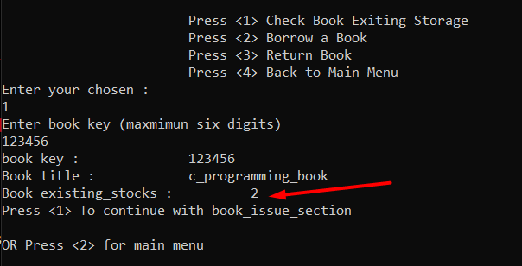
* Press<2> for move main menu
* Press <1> to continue with menu

**8. Check student information who has borrow book:**

* Go to main Manu
* Press <1> for student section
* 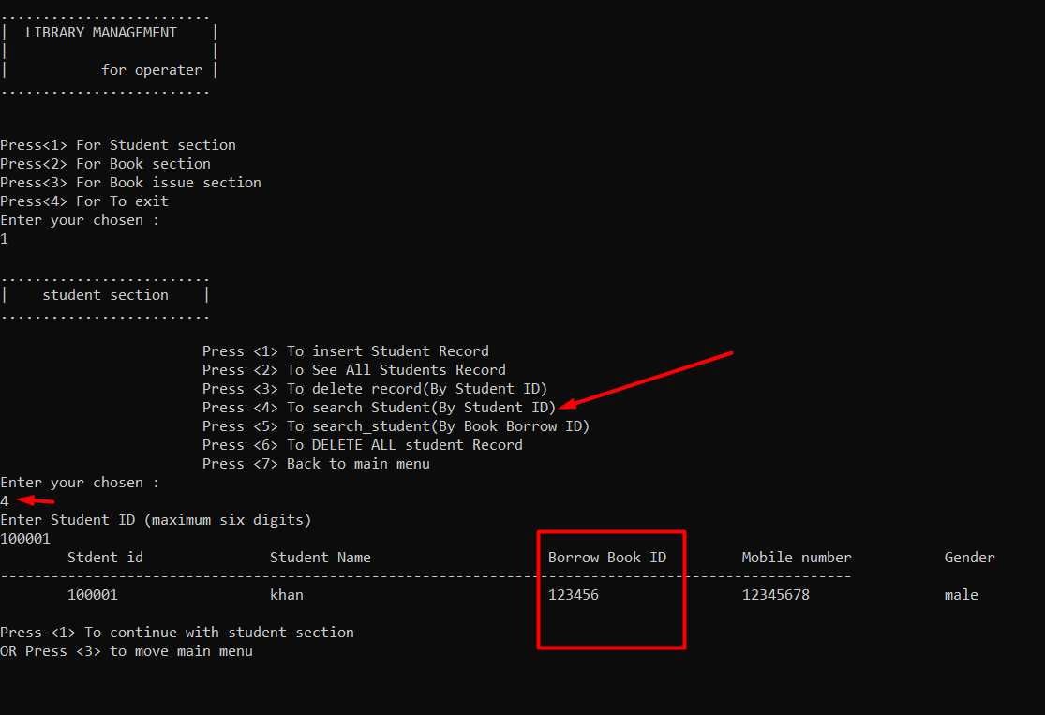

**19. Try to take another a book borrow again, who has already take a book**

* Go to the main menu
* Press <3> for book issue
* Press <2> for Borrow book
* 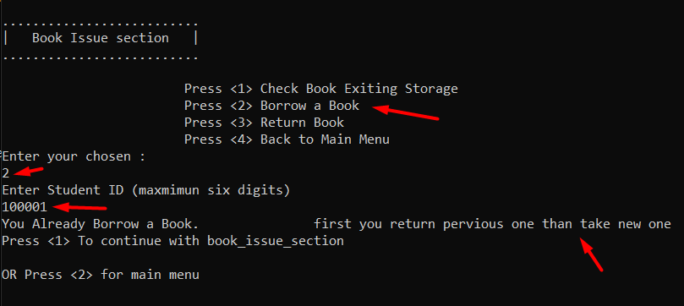
* First to return your previous book

**10. Return borrowed book**

* Go to main menu
* Press <3> for Book issue section
* Press <3> Return book
* Enter student id
* 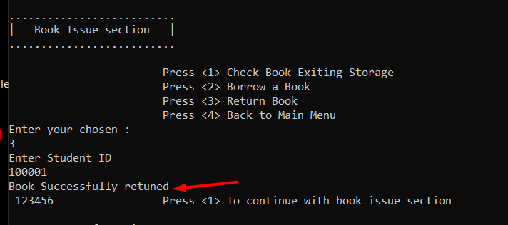
* Book return successful

**11. Check student information who has Return book**

* Go to main menu
* Press <1> for student section
* Press <4> to search student (by student id)
* Enter student id for checking
* 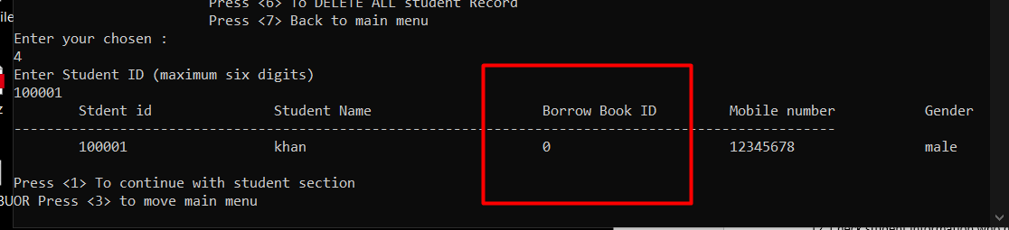

**12. Check return book stocks (should increasing)**

* Go to the main menu
* Press <2> for book section
* Press <3> for see book record
* Enter book ID:
* 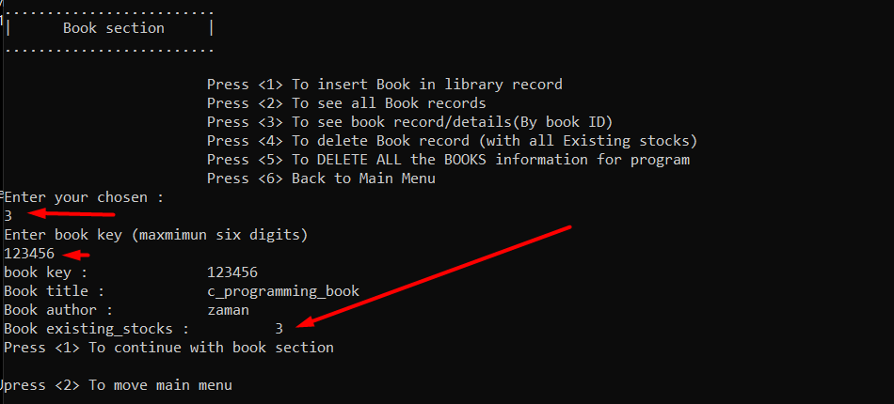

**13. Delete book from this program**

* Go to the main menu
* Press <2> for book section
* Press <4> for delete one book from store
* Enter book id
* 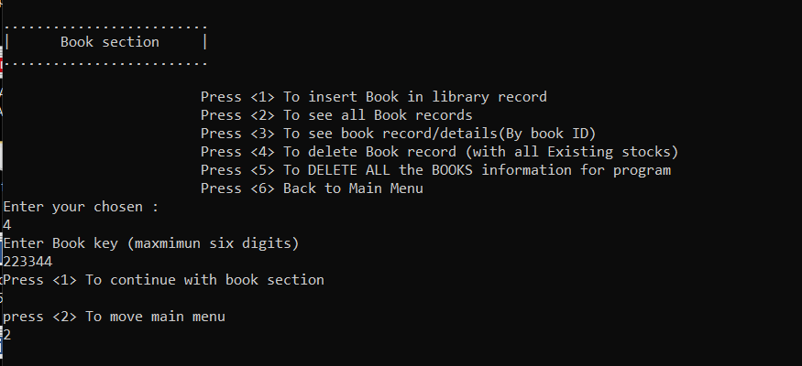
* Show this book is or not in store
* 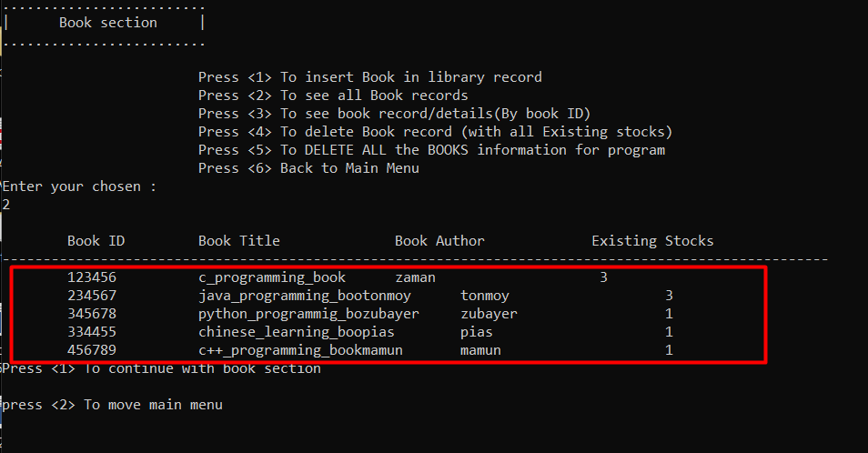
* English_learing_book is not this store

**14. Delete student information from this program**

* Go to main menu
* Press <1> for student section
* Press <3> for delete one student from library management program
* 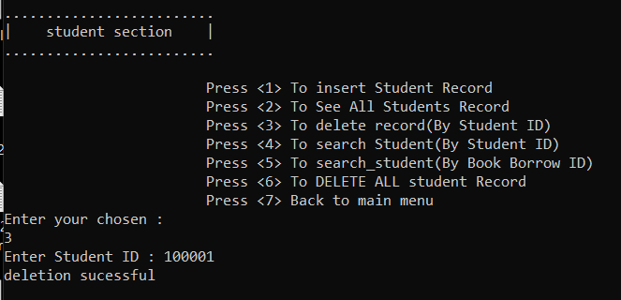
* Show the char of student register
* 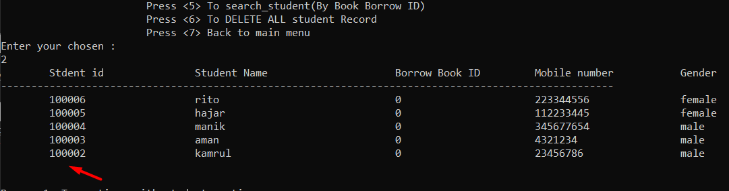
* Number one is missing

**15. Delete all the information of student**

* Go to main menu
* Press <1> for student section
* Press <6> Delete all student information
* 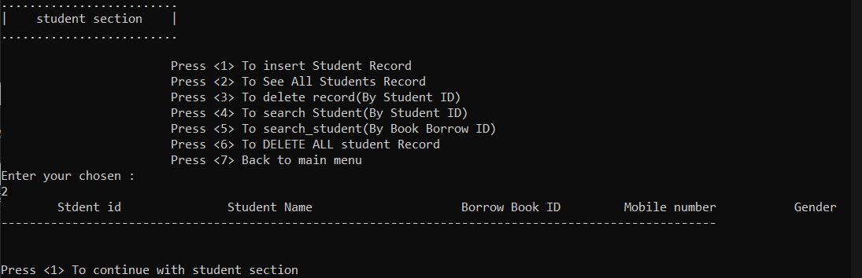
* There hasn’t any information

**16. Delete all the information of book**

* Go to the main menu
* Press <2> for book section
* Press <5> for delete all the book information
* 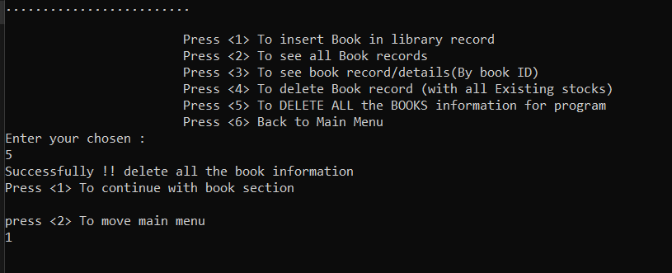
* Show book chart
* 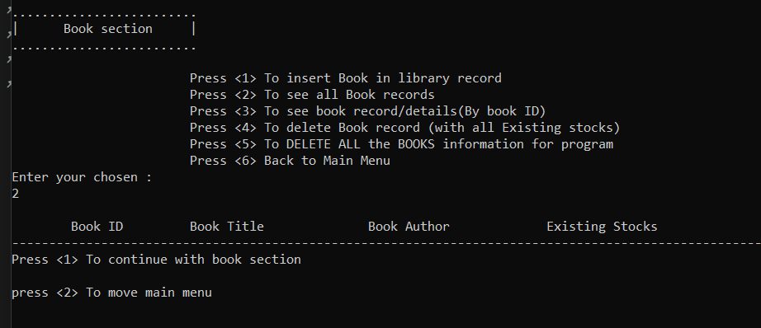
* There hasn’t any boo information

**17. Terminate this program**

* Go to the main menu
* Press <4> to exit this program/software
* 